12.3  
1. Show your plot of the cross-validated deviance of the model against the regularization variable. This plot should come from cv.glmnet

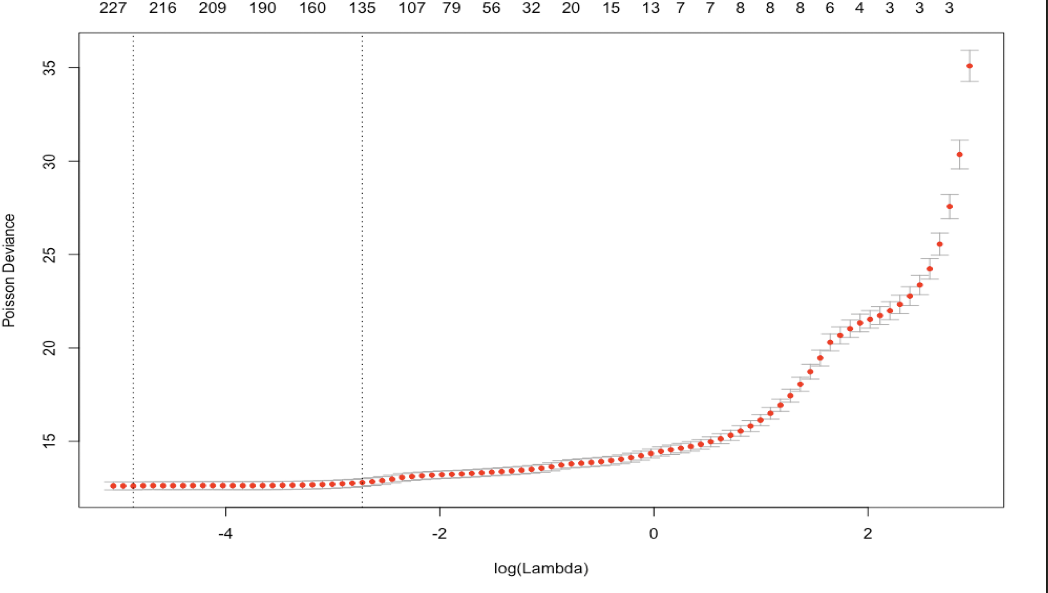

Page 2:  
2. Indicate the value of regularization constant that you choose, and show the scatter plot of true values vs predicted values for your training data

* I choose lambda.min = 0.00771056

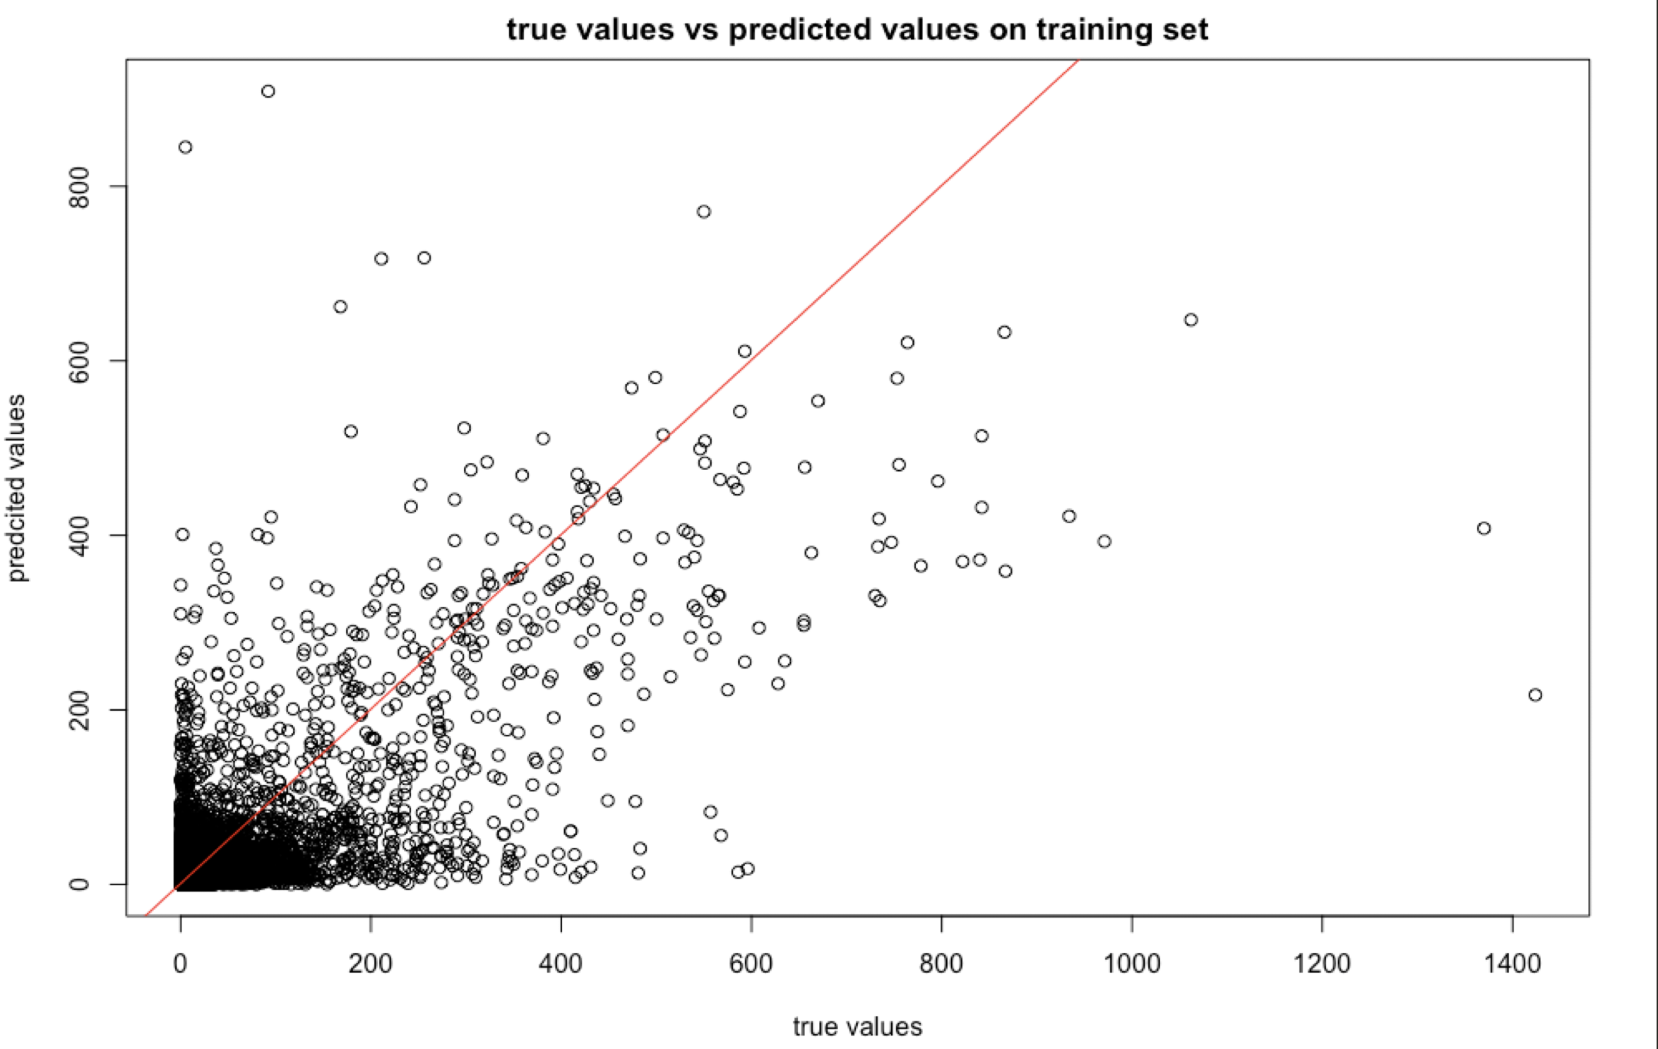

Page 3:  
3. Indicate the value of regularization constant that you choose, and show the scatter plot of true values vs predicted values for your testing data

* I choose lambda.min = 0.00771056

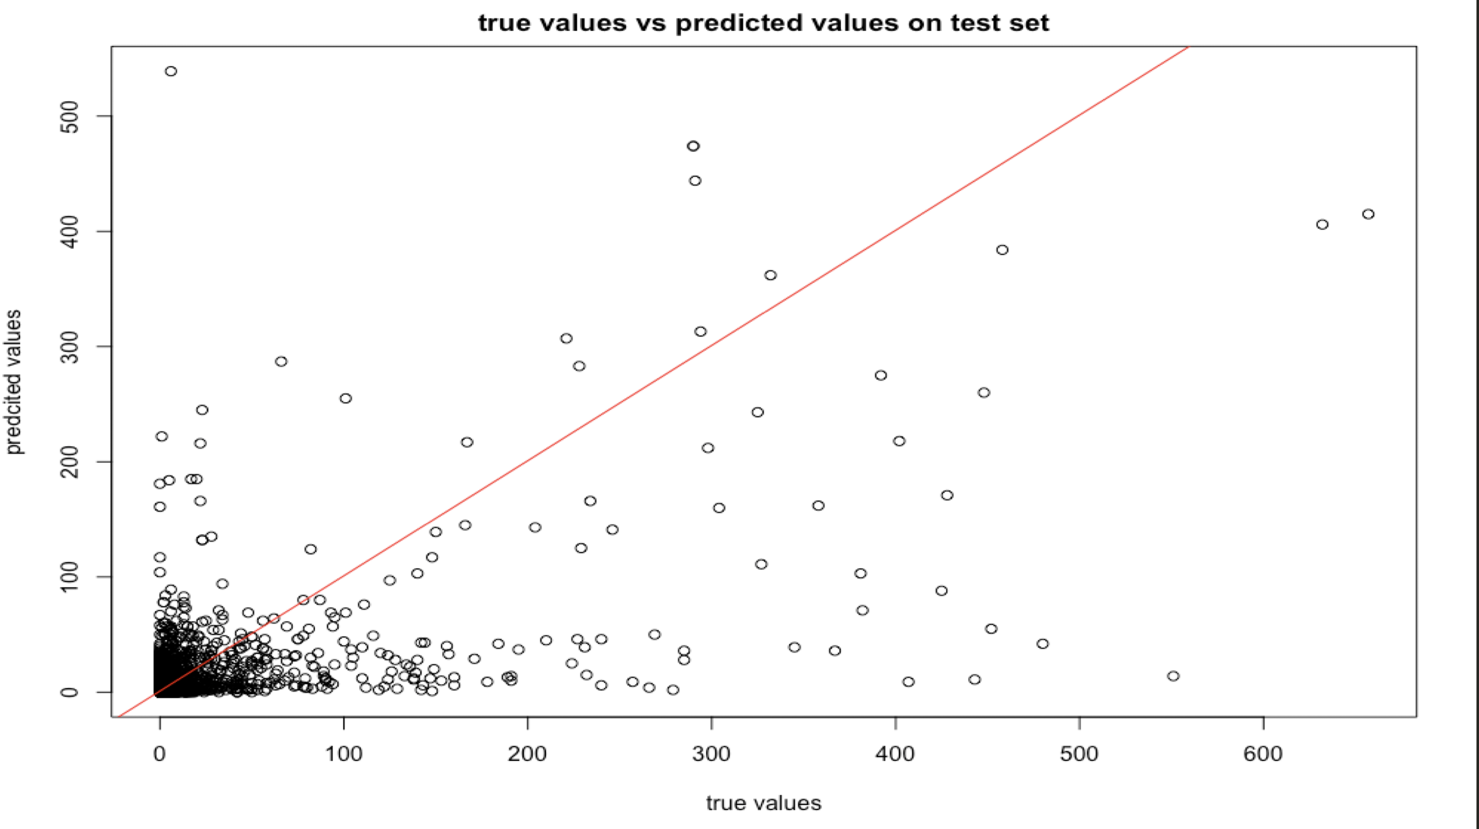

4. Compare the two plots and comment on the performance of the model. Provide comment on why this regression is difficult.

Page 4:  
12.4  
5. Show the plot of the classification error of the model against the regularization variable. Indicate the value of regularization constant of your choice and provide comment on the model performance compared with the baseline. Remember to include the classification accuracy in the comparison.

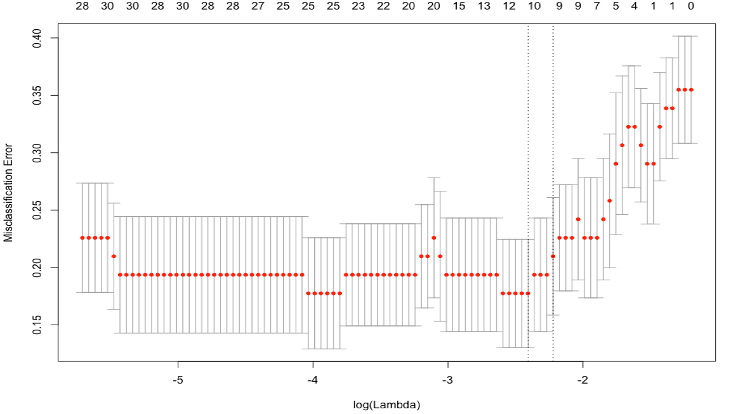

* My chosen regularization constant = 0.09016021 (lambda.min)
* Baseline accuracy: 0.6451613
* This model’s accuracy: 0.8709677
* Compared with the baseline that predicts the most common class, this model’s accuracy is a lot better.

Page 5:  
12.5  
6. Predict gender with the features. Show the plot of the classification error of the model against the regularization variable. Indicate the value of regularization constant of your choice and provide comment on the model performance compared with the baseline. Remember to include the classification accuracy in the comparison.

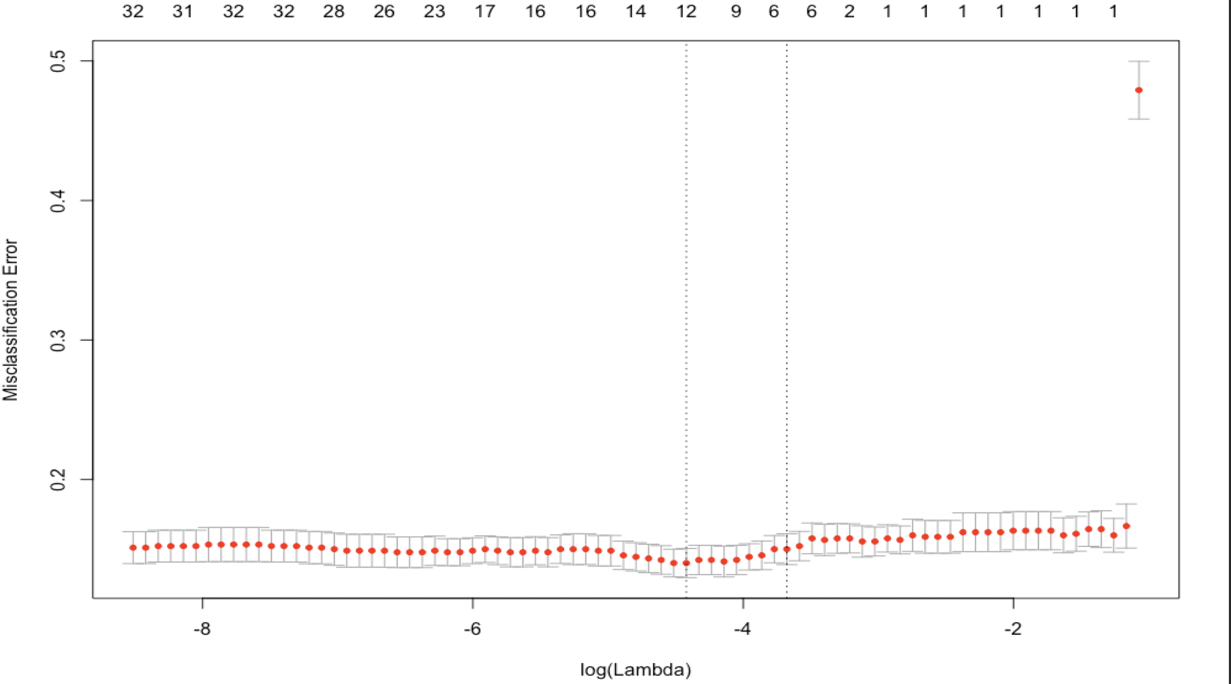

* My chosen regularization constant = 0.01202526 (lambda.min)
* Baseline accuracy: 0.50883 (predicting the most common gender male)
* This model’s accuracy: 0.8642384 (obtained using ‘predict’)
* Compared with the baseline that predicts the most common class, this model’s accuracy is a lot better.

Page 6:  
7. Predict the strain of a mouse with the features. Show the plot of the classification error of the model against the regularization variable. Indicate the value of regularization constant of your choice and provide comment on the model performance compared with the baseline. Remember to include the classification accuracy in the comparison.

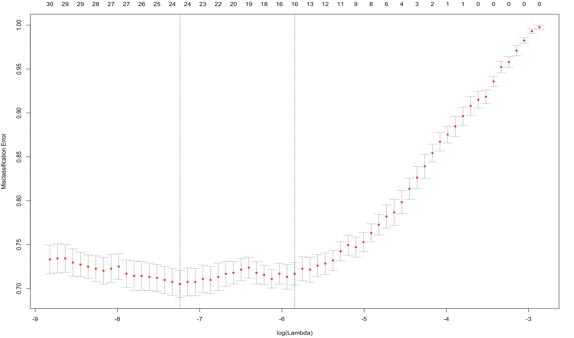

* My chosen regularization constant = 0.0007172174 (lambda.min)
* Baseline accuracy:
  + 0.01818182 (predicting a strain at random (**theoretical** **value**))
  + 0.02797203 (predicting a strain at random (**through simulation**))
* This model’s accuracy: 0.6655012 (obtained using ‘predict’)

Page 7:  
8. 1 page Code screenshot. It should include code for using glmnet, making the plot and data preprocess. 